Using AWS Glue to Transfer Data from S3 to Redshift

To Begin with the Lab

Summary of the Lab
In this lab, an ETL pipeline was created using AWS Glue to extract venue data from Amazon S3, perform schema transformations and UUID generation, and load the transformed data into Amazon Redshift. Before creating the ETL job, prerequisites such as an S3 VPC endpoint, AWS Glue IAM role, Redshift security group modifications, and a Glue-Redshift connection were configured. A visual ETL workflow was then built using the AWS Glue Visual Editor, where source data was read from an S3 location, transformed, and written into a Redshift table. Finally, the ETL job was executed and validated by confirming that 202 records were successfully loaded into the target Redshift table.

Understanding AWS Glue ETL Jobs
An AWS Glue ETL Job is a serverless data integration service that extracts data from one source, transforms it according to business requirements, and loads it into a destination system. AWS Glue automatically provisions the infrastructure required to run ETL workloads and provides visual and code-based development options. It is commonly used to move data between services such as Amazon S3, Amazon Redshift, databases, and data lakes. This eliminates the need to manage ETL servers manually while enabling scalable data processing.
Example:
A company stores daily sales files in an Amazon S3 bucket. The files contain columns such as store_id, product_id, and sales_amount, but the analytics team requires an additional transaction_uuid column before loading the data into Amazon Redshift. An AWS Glue ETL job reads the S3 files, generates the UUID values, and loads the transformed dataset into Redshift for reporting and analytics.

Lab Steps
Prerequisites
- Sign in to the AWS Management Console.
- Ensure an Amazon Redshift cluster is already available. If not, make one
- Ensure the source data file(tickit) is available in an Amazon S3 bucket. If not, make one and upload it.
- Create a target schema and table in Amazon Redshift for loading transformed data.

Create AWS Glue IAM Role
- Navigate to IAM → Roles → Create role.
- Select AWS Service as the trusted entity.
- Choose AWS Glue as the service.
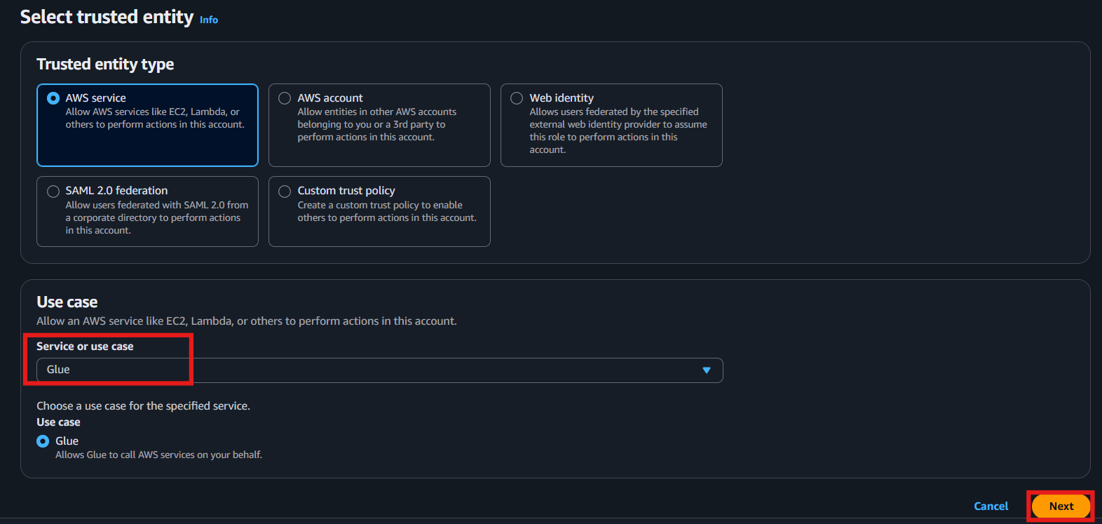
- Attach the following managed policies:
  - AmazonS3FullAccess
  - AWSGlueServiceRole
  - AWSGlueConsoleFullAccess
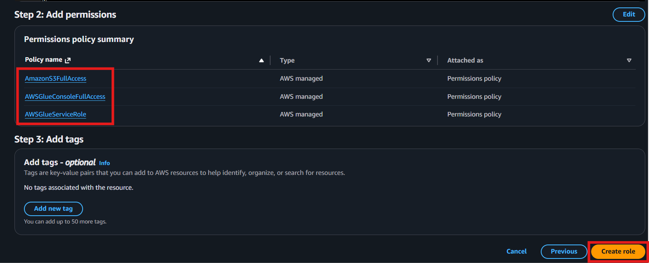
- Create the role and note its name for later use.
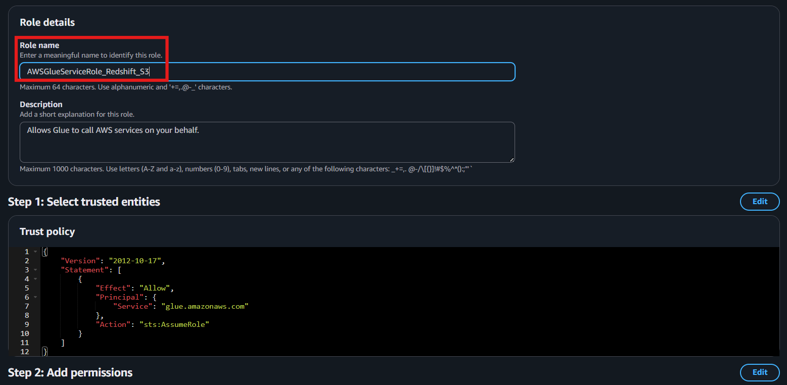
Create Amazon S3 VPC Endpoint
- Navigate to VPC → Endpoints → Create endpoint.
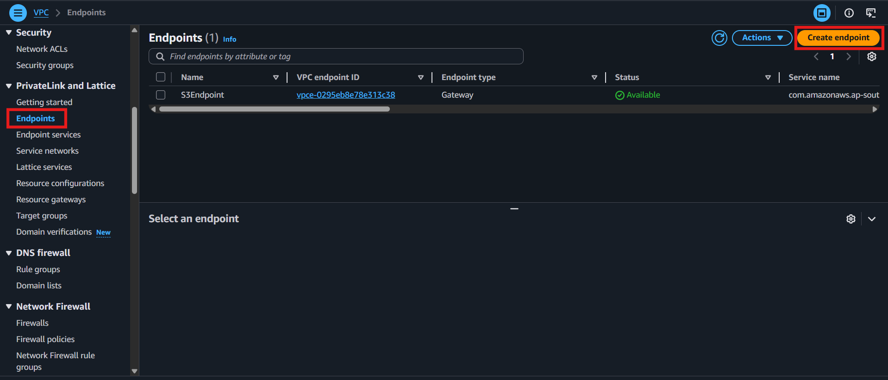
- Enter a name for the endpoint.
- Select AWS Services.
- Search and select the regional Amazon S3 service endpoint.
- Select Gateway endpoint type.
- Choose the VPC containing the Amazon Redshift cluster.
- Select the associated route table.
- Click Create endpoint.

Configure Amazon Redshift Security Group
- Navigate to Amazon Redshift → open the cluster.
- Open the attached Redshift security group.
- Add a self-referencing inbound rule:
  - Type: All TCP
  - Source: Same Redshift security group
- Save the security group changes.

Create Target Table in Amazon Redshift
- Navigate to Amazon Redshift → Query Editor v2.
- Create the target table in the Glue schema.
CREATE TABLE glue.venue (
venueid_src SMALLINT NOT NULL ENCODE az64,
venuename VARCHAR(100) ENCODE lzo,
venuecity VARCHAR(30) ENCODE lzo,
venuestate CHAR(2) ENCODE lzo,
venueseats INTEGER ENCODE az64,
venue_uuid VARCHAR(50),
PRIMARY KEY (venue_uuid)
);
- Verify the table is empty.
SELECT COUNT(*) FROM glue.venue;
Create AWS Glue Connection
- Navigate to AWS Glue → Data Catalog → Connections.
- Click Create connection.
- Select Amazon Redshift.
- Choose the detected Redshift cluster.
- Enter:
  - Database: dev
  - Username and Password (or use AWS Secrets Manager)
- Click Next.
- Enter connection name:
  - Glue Redshift Connection
- Click Create connection.

Test AWS Glue Connection
- Select the newly created connection.
- Click Actions → Test connection.
- Select the previously created Glue IAM role.
- Confirm the test execution.
- Verify the connection status shows successful connectivity to Amazon Redshift.

Create AWS Glue ETL Job
- Navigate to AWS Glue → ETL Jobs.
- Select Visual ETL.
- Add an Amazon S3 source node.

Configure Amazon S3 Source
- Select source type as S3 Location.
- Click Browse S3.
- Select the folder containing the venue data file.
- Choose:
  - Format: CSV
  - Delimiter: |
- Disable First row contains column names.
- Start a preview session using the Glue IAM role.
- Verify the data preview loads successfully.

Apply Schema Transformation
- Click Add Transform → Change Schema.
- Configure the column names: venueid_src, venuename, venuecity, venuestate, venueseats
- Update data types:
  - venueid_src → SMALLINT
  - venueseats → INTEGER
- Validate the transformed schema using Data Preview.

Generate UUID Column
- Click Add Transform → UUID.
- Rename the generated UUID column to: venue_uuid
- Verify UUID values are generated in the preview data.

Configure Amazon Redshift Target
- Click Add Node → Target → Amazon Redshift.
- Select access type:
  - Glue Redshift Connection
- Choose:
  - Database: dev
  - Schema: glue
  - Table: venue
- Select Merge Data mode.
- Choose merge key: venue_uuid
- Configure updates when matching records are found.

Save and Configure Job
- Enter job name: demo-glue-s3-to-redshift-job
- Open the Job Details section.
- Verify:
  - Engine: Apache Spark
  - Latest AWS Glue Version
- Select Flex Execution to reduce execution cost.
- Click Save.

Run the ETL Job
- Click Run.
- Open the Runs tab.
- Monitor the execution status.
- Wait until the job completes successfully.

Verify Data in Amazon Redshift
- Navigate to Amazon Redshift → Query Editor v2.
- Execute the verification query:
SELECT COUNT(*) FROM glue.venue;
- Confirm that 202 records have been loaded into the target table.

Verification
- AWS Glue connection successfully connected to Amazon Redshift.
- AWS Glue automatically created the required network interface in the VPC.
- Source data was read from Amazon S3.
- Schema transformations and UUID generation were applied successfully.
- Data was loaded into the glue.venue table.
- Final validation confirmed 202 records were inserted into Amazon Redshift.

